**DIGITAL COMMUNICATION LAB**

**E.C.E. DEPARTMENT**

**NIT CALICUT**

[](https://www.bing.com/images/search?q=nitc+logo&id=1D1CB8699EF6D9F58212DEB2373942BFAB752F7D&FORM=IQFRBA)

EXPERIMENT -10

**CDMA SOFTWARE**

Date:09/10/2018

**SUBMITTED BY:**

BOJANAPALLY VEDASREE - B150734EC

BOLLARAM SRAVANI - B150783EC

CHAMALA VAMSI NARAYANA REDDY-B150530EC

CHAPALA LAKSHMI PRIYANKA - B150837EC

**AIM:**

To generate a pair of m-sequences of length 31 and to plot the normalized auto correlation of one and the cross correlation of the pair.

**THEORY:**

**Spreading sequences:**

In spread spectrum communications, typically in CDMA, the user data is multiplied with a spreading sequence to achieve spreading . When the signal is received, the spreading is removed from the desired signal by multiplying it by the same sequence that is exactly synchronized to the transmitted PN signal.When a despreading operation is applied to the interferers signals, ideally there is no further contribution to the user of interests signal level. In CDMA, each user is assigned a predetermined spreading sequence which has low cross correlation property with other users spreading sequences.

Spreading sequences are chosen based on their characteristics like autocorrelation, cross correlation properties etc. Some of the spreading sequences are:

Maximum length Pseudo Noise (PN) Sequence Gold Sequences

Walsh - Hadamard Sequences

**Pseudo Noise Sequence:**

These are noise like wide band spread spectrum signals are generated using the PN sequence. Pseudo random noise is a signal similar to noise which satises one or more of the standard tests for statistical randomness. PN sequences are deterministically generated, however they are almost like random sequences to an observer. Although it seems to lack any de nite pattern, pseudo random noise consists of a deterministic sequence of pulses that will repeat itself after its period.

Various pseudo random codes are generated using LFSR(Linear Feedback Shift Register).To generate a m-sequence, feedback connection of LFSRs are connected according to a primitive polynomial (generator polynomial).

**Primitive Polynomials:**

A generator polynomial is said to be primitive if it cannot be factored (i.e. it is prime), and if it is a factor of (i.e. can evenly divide) XN + 1, where N = 2m-1 (the length of the m-sequence)

**Maximum Length Sequences:**

Shift-register sequences having the maximum possible period for an r-stage shift register are called maximal length sequences or m-sequences. A primitive generator polynomial always yield an m-sequence. The maximum period of an r-stage shift register can be proven to be 2r - 1. The m-sequences has three important properties, i.e., balance property, run-length property and shift-and-add property.

MLSs are spectrally at, with the exception of a near-zero DC term.

An important property of MLS is that its auto - correlation function is essentially an impulse.

It is hence possible to measure the impulse response of linear systems by calculating the cross - correlation between the MLS and the system output signal. If x(k) is a known pseudo random sequence, there exists an e cient and very fast way to calculate the cross correlation function Rxy(k), called the Fast Hadamard Transform, or the FHT.

It is a deterministic signal, but has similar spectral properties as true random white noise. Since it is deter-ministic, it can be repeated precisely.

It is therefore possible to increase the SNR by synchronous averaging of the response sequences. Since it is periodic, the auto spectrum for the sequence consists of lines separated by 1/T.

It can be shown that the lines for frequencies well below the clock frequency are equal in magnitude and that the spectrum thus approximates white band - limited noise.

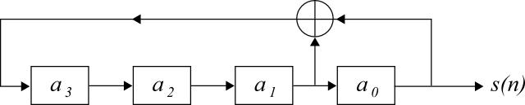

Figure 1: A pseudo random generator

**Walsh Codes:**

The Walsh code is an error-correcting code that is used for error detection and correction when transmitting messages over very noisy or unreliable channels. These codes are also known under Hadamard code and Walsh - Hadamard code.

It is an example of linear code over a binary alphabet that maps messages of length k to code words of length 2k.

In CDMA, it is used to de ne individual communication channels. Since Walsh code words are mathematically orthogonal, a Walsh-encoded signal appears as random noise to a CDMA capable mobile terminal, unless that terminal uses the same codeword as the one used to encode the incoming signal.

Hadamard codes are based on Hadamard matrices. A Hadamard matrix H of order n is an n x n matrix of 1s and -1s in which HHT = nIn (In is the n x n identity matrix).

**Gold Codes:**

Some pairs of m-sequences with the same degree can be used to generate Gold codes by linearly combining two m-sequences with di erent o set in Galois eld. All pairs of m-sequences do not yield Gold codes and those which yield Gold codes are called preferred pairs.

The generation of Gold codes is very simple. Using two preferred m-sequence generators of degree r, with a xed non-zero seed in the rst generator, 2r Gold codes are obtained by changing the seed of the second generator from 0 to 2r - 1. Another Gold sequence can obtained by setting all zero to the rst generator, which is the second

m-sequence itself. In total, 2r + 1 Gold codes are available.

**CODE:**

**%main code**

clc;

close all;

m = 5 ;

G = [ 1 0 0 1 0 1 0 1 1 1 1 0 1 0];

C1 = pnsq(G(1:7),m);

C2 = pnsq(G(8:14),m);

figure;

subplot(211) y1=cor(C1,C1);

stem(y1);

title(['Auto-correlation of ',num2str(2^m-1),'PN -sequence']);

subplot(212) y2=cor(C1,C2);

stem(y2);

title(['Cross-correlation of ',num2str(2^m-1),'PN -sequence']);

**%Correlation**

function [corr] = cor(C1,C2) C1 = [C1 C1];

corr = [];

N = length(C2);

for i=1:N

corr = [corr sum( C1(i:N+i-1).*C2 )/N];

end stem(corr);

end

**%PN Sequence**

function [pnseq] = pnsq(G,m)

S = [1 zeros(1,m-1)];

N = 2^m-1;

pnseq = [];

for i=1:N

pnseq = [pnseq S(1)];

k = mod( sum(S.*G(1:m)),2);

S = circshift(S',-1)';%circular left shift

S(m) = k;

end

pnseq = 2*pnseq-1;

end

**%Gold codes**

clc; clear ;

m = 5;

G = [1 0 0 1 0 1 0 1 1 1 1 0 1 0];

C11 = (pnsq(G(1:7),m)==1);

C12 = []; k = 3;

V11 = [C11 C11 C11 C11 C11];

for j=1:(2^m-1)

C12 = [C12 V11(k)];

k = k+5;

end

X1 = 2*xor(C11,circshift(C12',1)')-1;

X2 = 2*xor(C11,circshift(C12',2)')-1;

figure;

subplot(211);

cor(X1,X1);

title(['Auto-correlation of ',num2str(2^m-1),' length goldcode']);

subplot(212);

cor(X1,X2);

title(['Cross-correlation of ',num2str(2^m-1),' length goldcode']);

**%Hadamard codes**

clc; clear all;

N=32;

H32 = ones(N);

k = N/2;

while k>=1

for i=1:N/k

for j=1:N/k

if mod(i,2)+mod(j,2)==0

H32((i-1)*k+1:i*k,(j-1)*k+1:j*k)=~H32((i-1)*k+1:i*k,(j-1)*k+1:j*k);

end

end

end

k=k/2;

end H32 = 2*H32-1;

figure;

subplot(211);

cor([H32(7,:)], [H32(7,:)]);

title('Auto-correlation of 32 length Walsh-Hadamard code');

subplot(212);

cor([H32(3,:)],[H32(15,:)]);

title('Cross-correlation of 32 length Walsh-Hadamard code');

**PLOTS:**

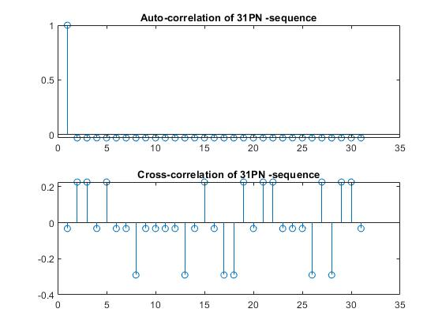

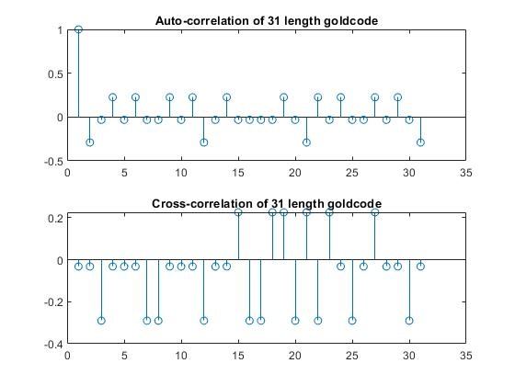

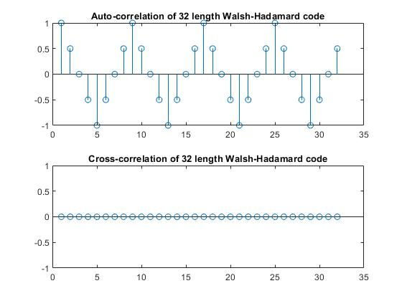

**RESULT:**

Generated a pair of m-sequences of length 31 and plotted the normalized auto correlation of one and the cross correlation of the pair.